NATIONAL JUNIOR COLLEGE
PRELIMINARY EXAMINATIONS
Higher 2
CANDIDATE
NAME

SUBJECT  CLASS |  | REGISTRATION NUMBER

CHEMISTRY  Paper 2 Structured  Answer on the Question Paper.  Additional Materials: Data Booklet | 9647/02  Fri 17 Sept 2010  2 hours

READ THE INSTRUCTIONS FIRST  Write your subject class, registration number and name on all the work you hand in.  Write in dark blue or black pen on both sides of the paper.  You may use a soft pencil for any diagrams, graphs or rough working.  Do not use paper clips, highlighters, glue or correction fluid.  Answers all questions.  The number of marks is given in brackets [ ] at the end of each question or part question. | For Examiner’s Use
 | 1
 | 2
 | 3
 | 4
 | 5
 | 6
 | 7
 | Total

This document consists of 18 printed pages and 0 blank page.

1 | Planning (P)  This planning task is about calamine lotion.
Calamine lotion is sometimes used to treat sun-burn.

It is a suspension of the solids zinc carbonate and zinc hydroxide in water.
A 100 cm³ bottle of the calamine lotion contains approximately 2-3 g each of zinc carbonate and zinc hydroxide.
A very small quantity of iron(III) oxide is sometimes present as colouring.

You are to design an experiment that will enable you to determine the total mass of zinc carbonate in 100 cm³ calamine lotion purchased from a shop.
The plan should not involve a titration.

You may assume that you are provided with
- chemicals and apparatus normally available in the school laboratory
- chemicals available are of concentrations of 0.5 mol dm^{–3}.

 | (a) | Use your knowledge of the chemistry of iron(III) oxide to suggest an appropriate test you could carry out to show that calamine lotion contains a small quantity of iron(III) oxide.  Give any observation(s) made and a chemical equation.
 |  |  |  | [2]

 | (b) | Plan and describe a procedure that would enable you to determine the total mass of zinc carbonate in a bottle of calamine lotion purchased from a shop.  Your plan should include the following:
- suitable quantities of materials to use
- specimen calculations to show how you worked out these quantities
- a labelled diagram of the apparatus used, where appropriate
 |  |  |  | [7]

1 | (c) | Describe how, using your result from (b), you would determine the percentage by mass of zinc carbonate in the solid materials suspended in the calamine lotion.
 |  |  |  | [3]
 |  |  | [Total: 12 marks]
2 | Chromium is a hard grey metal which is widely used in the manufacture of stainless steel because of its excellent corrosion resistance.  Potassium is a soft, silvery-white metal which oxidises rapidly in air.
 | (a) | Complete the following schematic diagram.  [2]
   |  |  | 3d |  |  |  |  |  | 4s |  |  | 4p
  Cr | [Ar]
  Cr in [Cr(NH₃)₆]³⁺ | [Ar]
 | (b) | Data about chromium and potassium are given below.
   | chromium | potassium
  First ionization energy / kJ mol^{–1} | 653 | 418
  Melting point / ºC | 1857 | 64
 |  | (i) | Although chromium atom has more electrons than potassium atom, the first ionisation energy of chromium is larger than that of potassium.  Suggest an explanation for this.  …………………………………………………………………………………………  …………………………………………………………………………………………  …………………………………………………………………………………………  …………………………………………………………………………………………  …………………………………………………………………………………………
 |  | (ii) | Explain the difference in their melting points.  …………………………………………………………………………………………  …………………………………………………………………………………………  …………………………………………………………………………………………  …………………………………………………………………………………………  …………………………………………………………………………………………  [4]
2 | (c) | The extraction of chromium involves a Thermite reaction of chromium(III) oxide with aluminium, which is a displacement reaction.
 |  | (i) |  |  | Write an equation for the Thermite reaction.  …………………………………………………………………………………………
 |  | (ii) |  |  | Given that the process is 75% efficient, calculate the mass of chromium metal that could be extracted from the reaction of 145 tonnes of chromium(III) oxide with 70 tonnes of aluminium.  (1 tonne = 10³ kg)  [3]
2 | (d) | Using some of the following E^{θ} values,
   |  |  |  | E^{θ} /V
  CrO₄^{2–} + 4H₂O + 3e– |  | Cr(OH)₃ + 5OH– |  | − 0.13
  Cr₂O₇^{2–} + 14H⁺ + 6e– |  | 2Cr³⁺ + 7H₂O |  | + 1.33
  Cr³⁺ + 3e– |  | Cr |  | − 0.74
  Cr³⁺ + e– |  | Cr²⁺ |  | − 0.41
  H₂O₂ + 2e– |  | 2 OH– |  | + 1.24
  H₂O₂ + 2 H⁺ + 2e– |  | 2 H₂O |  | + 1.77
  O₂ + 2 H⁺ + 2e– |  | H₂O₂ |  | + 0.68
 |  | predict with relevant observations what will happen when:
 |  | (i) |  | hydrogen peroxide is added to an acidified solution of potassium dichromate(VI).
 |  | (ii) |  | hydrogen peroxide solution is added to an alkaline solution of chromium(III) sulfate.
[3]

[Total: 12 marks]
3 | (a) | The industrial liquefaction of N₂O₃ involves its compression.
 |  | Suggest why the compression of N₂O₃ into a region of high pressure is an exothermic reaction. Why does the application of pressure cause the gas to liquefy at room temperature?
…………………………………………………………………………………………

…………………………………………………………………………………………

…………………………………………………………………………………………

…………………………………………………………………………………………

…………………………………………………………………………………………
[2]

 | (b) | (i) N₂O₃ is unstable above room temperature and decomposes to NO₂ and NO. A 2.5 g of sample N₂O₃ was allowed to decompose completely in a 0.20 dm³ vessel at 65ºC. Calculate the total pressure in the vessel.  [3]
3 | (b) | (ii) The total pressure in the vessel was found to be different from the value in (b)(i). Suggest a reason for the discrepancy.  …………………………………………………………………………………………..  …………………………………………………………………………………………..  …………………………………………………………………………………………..  [1]
 | (c) | The following sketch represents the distribution of molecular speeds of N₂O₃ at 65°C.  On the same axes, draw the distribution of the molecular speeds of NO.  Fraction of molecules  Molecular speed  Explain your answer.  ………………………………………………………………………………………….  ………………………………………………………………………………………….  ………………………………………………………………………………………….  [2]
 |  | [Total: 8 marks]

4  Δ  Δ | The following plot shows the variation of the Gibbs energy change, ΔG, with temperature, T, when separate samples of different substances were heated.  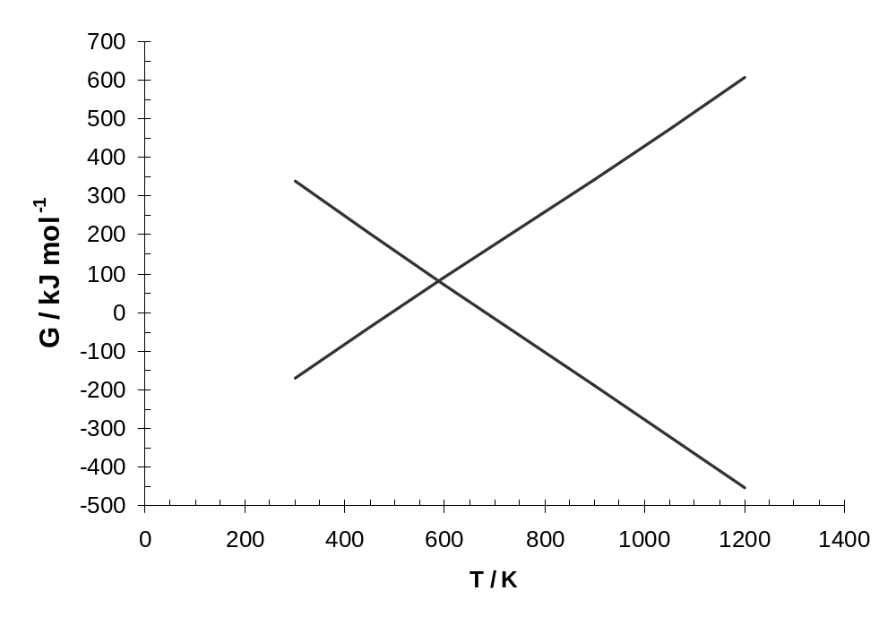  Graph I  Graph II
 | (a) | Which one of the graphs, I or II, shows the variation of ΔG with T when a sample of solid strontium nitrate, Sr(NO₃)₂, was heated?  Explain your choice by considering the Gibbs equation.
 |  |  | [2]

4 | (b) | Use your chosen graph in (a) to find a likely value for  - the enthalpy change of reaction when solid strontium nitrate was heated,  - the temperature at which solid strontium nitrate starts to decompose.  Indicate clearly how you arrive at your answers.
 |  |  | [3]
 | (c) | How would you expect the decomposition temperature of solid magnesium nitrate, Mg(NO₃)₂, to compare with that of strontium nitrate? Explain.
……………………………………………………………………………………….

……………………………………………………………………………………….

……………………………………………………………………………………….

……………………………………………………………………………………….
[2]

 | (d) | Describe what happens when water is added to the solid remaining after strontium nitrate has been heated. In what way(s) will this differ if magnesium nitrate is used instead of strontium nitrate?
……………………………………………………………………………………….

……………………………………………………………………………………….

……………………………………………………………………………………….

………………………………………………………………………………………..
[2]

 |  |  | [Total: 9 marks]

5 |  | (a) |  | (i) | 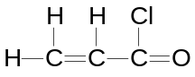Compound X, shown below, reacts with hydrogen bromide to form two products. Identify the major product formed and describe the mechanism for its formation.  Compound X
 |  |  |  | (ii) | Compound X can be synthesized into compound Y.
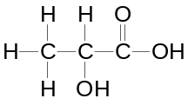

Compound Y

Suggest a synthetic route for converting compound X to compound Y, stating reagents and conditions used for each step in the synthesis.
 |  |  |  |  |  |  |  | [5]
5 | (b) The flow scheme below concerns the reaction of compound Y.  Concentrated NH₃  heat  2,4-dinitrophenylhydrazine  Orange solid R  Compound Q  Step I  Heat  to remove water  Compound Y  SOCl₂  Compound S  Compound P  C₆H₈O₄  I₂, NaOH(aq)  heat  Compound U  Compound V  +  Compound T
 |  |  |  | (i) |  | Give the reagents and conditions for Step I.  ……………………………………………………………………………………………
 |  |  |  | (ii) |  | Draw the structures of the organic compounds P to V in the boxes provided above.  [9]  [Total: 14 marks]
6 |  | As shown in Table 1 below, some of the common compounds of the elements of Period 3 are named as hydroxides and some as acids:  Table 1
  NaOH | sodium hydroxide
  Mg(OH)₂ | magnesium hydroxide
  Al(OH)₃ | aluminium hydroxide
  Si(OH)₄ | silicic acid (usually written as H₄SiO₄)
  P(OH)₃ | phosphorous(III) acid (usually written as H₃PO₃)
  S(OH)₂ | not known
 |  | (a) |  |  | State and explain two factors which determine the systematic variation in the acid-base behaviour of these compounds.
……………………………………………………………………………………...…...

…………………………………………………………………………………………..

…………………………………………………………………………………………..

…………………………………………………………………………………………..

…………………………………………………………………………………………..

……………………………………………………………………………………….....

[3]

6 | (b) | Al(OH)₃ is formed when aqueous sodium carbonate is added to aqueous aluminium nitrate. Explain the chemistry of this reaction.
 |  |  | [2]

6 | (c) | By considering the possible structure of S(OH)_{2,} suggest why it is not formed.
 |  |  |  | [1]
 | (d) | Complete the missing row in Table 1.
 |  |  |  | [2]
 |  |  | [Total: 8 marks]

7 | A protein found in the pituitary gland has the following amino acid sequence in one of its polypeptide strands:  -Arg-Cys-Tyr-Phe-Glu-Cys-Asn-Val-  The data on some of the amino acids are given in Table 2.
  Amino acid | Abbreviation | Molecular Mass | Formula of side chain  (R in RCH(NH₂)CO₂H) | pI
  Arginine | Arg | 174 | 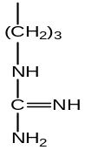 | 10.76
  Cysteine | Cys | 121 | 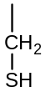 | 5.07
  Tyrosine | Tyr | 181 | 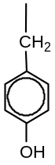 | 5.66
  Valine | Val | 117 | 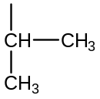 | 5.96
   |  | Table 2
 | (a) | The pH at which the amino acids exist as zwitterions is known as the isoelectric point, indicated in the table as pI.
 |  | (i) | Explain why arginine has a pI value of 10.76.
 |  |  |  | [1]

7 | (a) | (ii) | Draw the structural formula of the zwitterion formed from valine. | [1]

 | (b) | The polypeptide chain was folded in a β-pleated sheet structure.
 |  | (i) | Draw a diagram showing three strands of a β-pleated sheet structure of the protein involving the above amino acid sequence.  You can use R to represent the side chains of the amino acids by copying the formula below but writing it as a displayed formula. Leave space above and below your drawing so that you can draw one strand above and the other below.  –CHRNHCOCHRNHCOCHRNHCO–  Indicate clearly how the R groups are directed in the β pleated sheets. Indicate the hydrogen bonds between the strands by dotted lines.  [3]

7 | (b) | (ii) | The folding of polypeptide chains is due to the interactions of the R groups.  Suggest two possible types of R group interactions that can be formed by the amino acids in Table 2, stating clearly which pairs of amino acids are involved in the interaction.
 |  |  | [2]

7 | (c) | In an electrophoresis setup, a solution of three amino acids (Arg, Cys, Val) is placed at the centre of a gel placed in an aqueous solution of pH 6.  An electric potential is then applied through electrodes which are connected to the two ends of the gel strip. Under the applied potential, the three amino acids migrate from the centre of the gel.  ( + )  (  –  )  Cathode  Original position of the 3 amino acids  Gel strip at pH = 6  Anode  X
 |  | On the above diagram, indicate clearly the new positions of each amino acid in the gel strip.
 |  |  |  | [2]
 |  |  | [Total: 9 marks]

The End

